✴

**Document an existing experience**

Narrow your focus to a specific scenario or process within an existing product

**TIP**

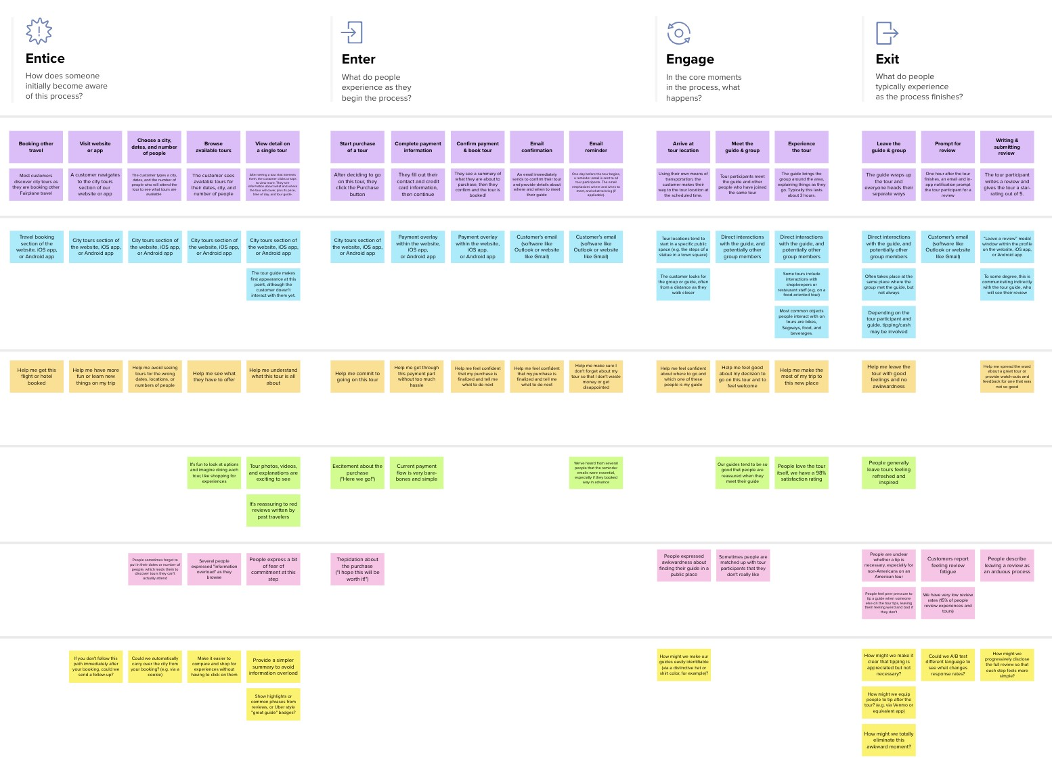

**Template**



Customer journey map

|  |  |  |  |  |  |  |  |
| --- | --- | --- | --- | --- | --- | --- | --- |
| or service. In the **Steps** row, document the step-by-s  typically experiences, then add detail to each of the | | | tep process someone  other rows.  **Entice**  How does someone initially become aware of this process? | **Enter**  What do people experience as they begin the process? | **Engage**  In the core moments in the process, what happens? | As you add steps to the experience, move each these “Five Es” the left or right depending on the scenario you are documenting.  **Exit**  What do people typically experience  as the process finishes? | **Extend**  What happens after the experience is over? |
|  | **SCENARIO** |  |
|  | **Browsing, booking, attending, and rating a local city tour** |  | **Displaying the message**  Notification **of helpdesk at the end of an order**  Notifiying about the Displaying an  helpdesk and the complement at the  recommended projects  for future help end of an order | **Greetings from helpdesk**  A greet and showing people what they are looking for will make people to find their approached place | Helpdesk Alternate  interaction way  The customer If customer does  products details not satisfied, the  collected by the helpdesk make a  helpdesk and it call to the  provide message customer care  based requirement employee | Display good messages  Displaying good looking messages at the end of the chat | The queries are noted by the helpdesk after the customer leaves |
| **Steps**  What does the person (or group) typically experience? | | |
| **Interactions**  What interactions do they have at each step along the way?  **People:** Who do they see or talk to?  **Places:** Where are they?  **Things:** What digital touchpoints or physical objects would they use? | | | Helpdesk and if needed At the end of the  can able to make order at the  communication with the  customer care employee dashboard  Helpdesk or call | Greeting from helpdesk and showing them the related contents either they can make use of the search buttons if they need any help | Helpdesk will provide the details about the requested products as per the customer requirement  Send normal messages or the problem gets solved | Thank you  message will  be sent as a  complement  to the user | Complemented  by thank you  messages and suggesing the  related products to the customers |
| **Goals & motivations**  At each step, what is a person’s primary goal or motivation? (“Help me...” or “Help me avoid...”) | | | Without any interruptions  and breaks a customer To solve the conflicts  can make use of things for the customers  by 24/7 | To intimate customer for use this service | The questions will be displayed as customer prefers | Customer Getting  satisfication feedback | Checks whether the customer problmes gets solved |
| **Positive moments**  What steps does a typical person find enjoyable, productive, fun, motivating, delightful, or exciting? | | | Cinflicts of the customer gets solved quickly | Starting a user friendly chats | Multiple language chat and also able to translate to its their own mother tongue | Queries were gets asked by the user | Customer satisfication |
| **Negative moments**  What steps does a typical person find frustrating, confusing, angering, costly, or time-consuming? | | | When the customer themself having a problem with a product or anything | If they feel irritate on the start chat | When they do not find their language | If the issues does not solved clearly and properly | Customer got frusrtated while chating |
| **Areas of opportunity**  How might we make each step better? What ideas do we have? What have others suggested? | | | By sending Updating with complements after required to customer  every usage needs | Their profile gets updated | Asking their comfortable language | Getting feedback | Managing FAQ on dashboard |



Use this framework to better understand customer needs, motivations, and obstacles by illustrating a key scenario or process from start to finish.



When possible, use this map to document and summarize interviews and observations with real people rather than relying on your hunches or assumptions.



Created in partnership with



[**Share template feedback**](https://muralco.typeform.com/to/CiqaHVat?typeform-source=app.mural.co)



**Need some inspiration?**

|  |  |  |  |  |  |  |  |  |
| --- | --- | --- | --- | --- | --- | --- | --- | --- |
|  |  |  |  |  |  |  |  |  |
|  |  |  |  | |  |  |  |  |

|  |  |  |  |  |  |  |  |  |
| --- | --- | --- | --- | --- | --- | --- | --- | --- |
|  |  |  |  |  |  |  |  |  |
|  |  |  |  | |  |  |  |  |

See a finished version of this template to kickstart your work.

[**Open example**](https://app.mural.co/template/f59f644b-b4b4-47b5-9ed6-3a8c71ceb612/896b31fe-5597-40ef-9b06-3811a1a45ace)